**Saish S Yadav A084**

**Jenkins Pipeline to Deploy Nginx Docker Container**

**I encountered permission issues while setting up Jenkins, as administrative access was required to execute Docker commands on my system.**

**Step 1: Set Up Project Structure**

1. **Create Project Directory:  
   Commands -**

mkdir nginx-docker

cd nginx-docker

1. **Create Dockerfile:**

FROM nginx:latest

COPY ./html /usr/share/nginx/html

1. **Create HTML Directory:**

**Command -** mkdir html

1. **Create index.html:**

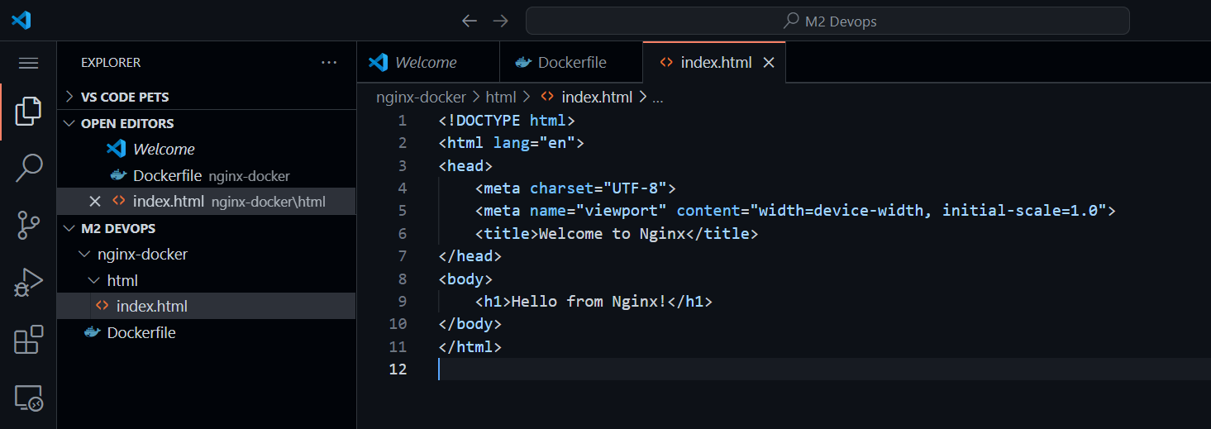

**Step 2: Initialize a Git Repository**

1. **Initialize Git**:

**Command** - git init

1. **Add Files and Commit**:

**Command** -   
git add .

git commit -m "Initial commit with Dockerfile and HTML"

**Step 3: Create a Remote Repository**

1. **Create Repository**:

Use GitHub or another service to create a new repository named nginx-docker.

1. **Link Remote Repository**:

Command -  
git remote add origin https://github.com/yourusername/nginx-docker.git

git push -u origin main

**Step 4: Set Up Jenkins**

1. **Log into Jenkins**.
2. **Install Plugins**: Go to "Manage Jenkins" > "Manage Plugins" and ensure the "Docker" and "Pipeline" plugins are installed.
3. **Create a New Pipeline**:

Name: Nginx Deployment

Type: Pipeline

**Step 5: Configure the Jenkins Pipeline**

1. **Pipeline Configuration**:
   * Set "Definition" to "Pipeline script."
2. **Add the Pipeline Script**:

pipeline {

    agent any

    stages {

        stage('Checkout') {

            steps {

                git url: 'https://github.com/yourusername/nginx-docker.git', branch: 'main'

            }

        }

        stage('Build Docker Image') {

            steps {

                script {

                    docker.build("nginx-app")

                }

            }

        }

        stage('Deploy to Local Docker') {

            steps {

                script {

                    sh "docker stop nginx-container || true"

                    sh "docker rm nginx-container || true"

                    sh "docker run -d --name nginx-container -p 80:80 nginx-app"

                }

            }

        }

    }

    post {

        always {

            sh "docker rmi nginx-app || true"

        }

    }

}

3. **Save the Pipeline**.

## Step 6: Run the Pipeline

1. **Build the Pipeline**: Click “Build Now” and monitor the console output.

## Step 7: Verify Deployment

1. **Check Deployment**: Open a browser and go to http://localhost to see "Hello from Nginx!".